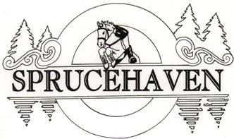
Sprucehaven Farm Combined Training Prize List 2026

Sunday July 26, 2026
Sprucehaven Farm – 343279 Ebenezer Rd RR#2 Mt Elgin ON N0J 1N0
General Information
Every class offered is run by the rules of Equine Canada and will be judged accordingly. To keep in the spirit of the “schooling show” eliminated competitors may be allowed to continue if the judge or show organiser allow it. Competitors of the riding phases must be a member of Ontario Equestrian.

Closing date- Wednesday July 22nd at 11:00pm

After closing date, $25 admin fee applies. Riders have 2 more days for payment (with the $25 late admin fee) after that, riders will not be included on the schedule.
Cancellations accompanied by a vet certificate will be accepted with a full refund less administration fee post-closing date and pre-show date. Cancellations on show day for any reason and no shows will be charged the full amount.

Schooling entries will be accepted. These will be subject to the same judging conditions as a regular entry and must pay the posted entry fee. Schooling entries are NOT eligible for ribbons or awards but will be scored.

Horses may be used in 2 divisions (up to 4 classes) total and may be used with different riders, but not within the same division.

Entries
Entries will be done through Competeeasy.com. Entries open 30 days prior to the show.

Awards
Ribbons to 6th place. Prizes to 3rd place

Year-end points
The same horse and rider combination may accumulate points towards year end awards.
1st- 10 points
2nd- 8 points
3rd- 6 points
4th- 5 points
5th- 4 points
6th- 3 points

Riders must ride at a minimum of 3 shows on the same horse in the same divisions to qualify for year end points.

Office
The show office is in the building to the left as you drive up the driveway. Please check in and to pick up your numbers and let us know you have arrived. Sprucehaven Farm will have our office manager available to answer any questions.

Fees
Compete Easy is the entry platform.

Attire
In the spirit of a schooling show, braiding and show attire is optional. Riders should be turned out neat and tidy. Helmets must be worn by everyone mounted on a horse - no exceptions.

Coaching
The lowest levels in each discipline will allow for coaching during the round. 0.40m jumper and 0.4m combined (jumping portion only). This is to give competitors and horses at the lowest levels additional confidence.

Eliminations
Riders may only have 3 refusals before being eliminated. Riders can continue once eliminated, however at the 4th refusal they must retire from the course.
In the event of elimination, the riders' scores will not count towards ribbons or year- end totals. Eliminated riders may be coached during the remainder of the class.

Jumping the wrong jump on course is cause for immediate elimination, however the rider may continue or take a courtesy jump at the judges discretion.

Rider falls are an automatic elimination. The rider may not continue until being cleared by the medic

Facility Map

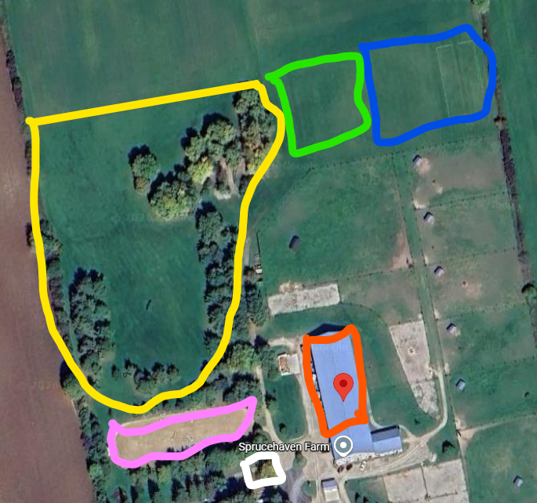
Yellow - Showjumping and Short Course show area
Blue – Parking
Green - Showjumping and Short Course Warm up
Pink – Dressage show ring
Orange – Dressage Warm up in Indoor Arena
White – Show office
LAYOUT SUBJECT TO CHANGE DUE TO WEATHER CONDITIONS AND FOOTING

COMBINED TRAINING DIVISIONS

Scoring
Placings will be determined by dressage penalty points plus stadium penalty points.
Stadium penalty points are +4 points per knock down & + 4 points per refusal. Riders will be eliminated upon the 3rd refusal.

Stadium Warm up Round
A coach is allowed in the ring with the rider for the clear round. The rider will have a MAXIMUM of 2 minutes in the ring riding the course. In the event that the coach has multiple riders they may be in the ring at the same time, however only 1 horse may be jumping the course at a time.

Division | Dressage Test | Description |  | Price
Warm Up Round |  | 2 minutes in the ring max to school over the course |  | $30
EV 40 | OCTS Walk/ Trot | Combined dressage & stadium division |  | $100
EV 60 | OCTS 60 test | Combined dressage & stadium division |  | $100
EV 75 | OCTS 75 test | Combined dressage & stadium division |  | $100
EV 85 | OCTS 85 test | Combined dressage & stadium division |  | $100

Dressage will rule according to the rules of Equestrian Canada. To keep in the spirit of the “schooling show” eliminated competitors may be allowed to continue if the judge or show organiser allow it. The judge will be allowed to give verbal feedback.

Eliminated riders may continue their test unless whistled out by the judge due to safety or time concerns. Their tests will be completed for feedback purposes, but will not be counted towards the competition or year end totals.

Classes-
Combined tests can be found at- https://www.ontariocombinedtrainingseries.com/dressagetests

Tests
Tests will be emailed to the competitors through the ScoreBoard Ap with Compete Easy.

Test of Choice
Please inform the show organizer by closing which test you will ride for the test of choice. You can choose any test from the same level of the same division. English tests can be found at http://www.cadora.ca/dressage-tests/

Dressage Judge:
July 26th – Amanda Vanderkuyl

Show Jumping and Short Course Judge:
TBA

SHORT COURSE DIVISIONS
Sprucehaven Farm will offer a short course division which will include 3 levels. It will include showjumping jumps, then the rider will leave the showjumping ring and go out into the grass cross country field and jump up to 6 cross jumps, returning into the showjumping ring and finishing over 2 show jumping jumps. Most cross-country jumps will be logs and some portables and inviting. Water crossing option may be included on the SC75 and SC85 divisions. There will be NO WARM UP round for the Short Course Division.

Scoring will be based on:

Jumping Faults:

4 pp for knockdown of show jumping jumps
4 pp for refusal of Show jumping jumps
20 pp for refusal of cross country jumps

Time Faults:

SC60 will not be timed but time limit applies
SC75 and SC85 will be based on MPM and .4 pp applied to 1 second over optimum time

Rider Falls:

Rider falls will result in elimination and rider will be checked by on site medic before leaving property. If medic approves rider to continue, the rider and coach may school the jumping course after the competition is over at no cost.

Class | Description | Height/Time | Price
SC 60 | Walk/Trot/Canter trot max height 60 cm | Not timed, time limit applies | $130/ class
SC 75 | Walk/Trot/Canter, max height 75 cm | Based on275 mpm with optimum time | $130/ class
SC 85 | Walk/Trot/Canter Max height 85 cm | Based on 300 mpm with optimum time | $130/ class

Dog Policy
Dogs are permitted, but must be leashed.

Stabling
Limited Stabling available FCFS. Day- $50 & does not include bedding.

Ride Times
Ride times for dressage & eventing, will be posted online 3 days before the show date. www.sprucehaven.com or Sprucehaven Facebook page https://www.facebook.com/groups/310938941322

Live Scores
Live scores will be posted online on Compete Easy

Food
TBA

Inclement weather
In the event of dangerous weather (lightening, tornado, thunderstorm, or hail) the show will be put on hold until the weather passes. All participants please load horses onto your trailers or come into the indoor arena.

Contact Information
Linda Plank – Sprucehaven Farm lindap@sprucehaven.com 519-318-2722

